**Fatima Shafique**

**SU 92 BSAIM S24 – 036**

**Task : 3**

**LUHN ALGORIDUM :**

The code implements the Luhn algorithm to validate a credit card number. It doubles every second digit starting from the right, subtracts 9 if the result is greater than 9, and checks if the total sum is divisible by 10. If it is, the card number is valid.

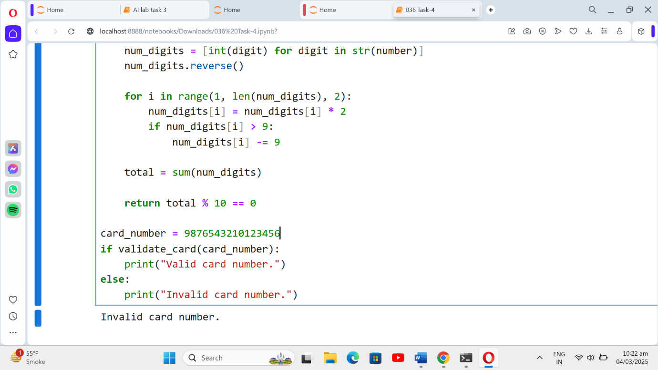

**REMOVE PUNCTUATIONS**:

The code defines a function that removes punctuation from a given text by iterating through each character and excluding any that are special characters. It returns the cleaned text.

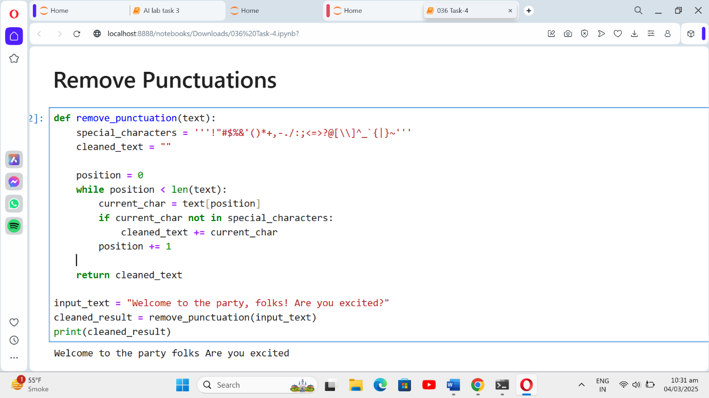

**SORT SENTENCE :**

The code defines a sort function that takes a sentence, splits it into words, sorts the words alphabetically, and then combines them back into a sentence. It returns the sorted sentence after removing any trailing spaces.

